Table of Contents
1. INTRODUCTION 2
2. SOFTWARE DEVELOPMENT LIFE CYCLE (SDLC) 3
4. UML DIAGRAMS 7
Use Case Diagram 7
Activity Diagram 9
5. PROTOTYPE DEVELOPMENT 12
6. GIT AND GITHUB INTEGRATION 15
7. PROJECT MANAGEMENT 17
NETWORK DIAGRAM 19
8. LICENSE, DESIGN QUALITY AND SDG RELEVANCE 20
Software License 20
9. CONCLUSION 21
10. REFERENCES 22

1. INTRODUCTION

The Secure and Smart Banking System is a digital banking platform designed to provide secure, efficient, and convenient banking services to customers. The system allows users to register, log in securely, transfer money, pay bills, check account balances, and view transaction history through a mobile application. The project addresses challenges faced in traditional banking such as long queues, limited accessibility, and security concerns. This system contributes to digital transformation in the financial sector and supports innovation through technology-driven banking solutions.

2. SOFTWARE DEVELOPMENT LIFE CYCLE (SDLC)

The Waterfall SDLC model was selected for this project.

Requirements Analysis

Requirements were collected to identify user needs such as account management, money transfers, bill payments, and transaction tracking.

System Design

The system architecture, database structure, and user interface were designed to ensure security and usability.

Development

The application was developed based on the approved design specifications and functional requirements.

Testing

Testing was conducted to verify system functionality, security, and performance.

Deployment

The completed application was prepared for release to end users.

Maintenance
Future updates, bug fixes, and security improvements will be performed during maintenance
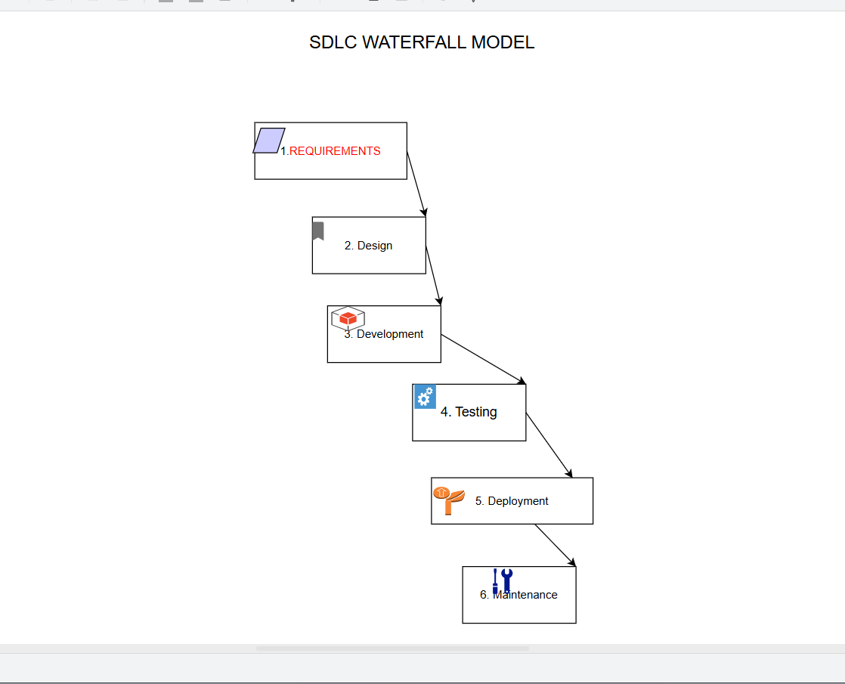
3. SYSTEM ARCHITECTURE DESIGN

The Secure and Smart Banking System follows a three-tier architecture.

Presentation Layer

This layer consists of the mobile application interface used by customers.

Application Layer

This layer processes transactions, authentication, and business logic.

Data Layer

This layer stores customer accounts, transactions, and banking records.

Component Interaction

Customers interact with the mobile application. The application communicates with the server, which processes requests and retrieves data from the database. Payment services are handled through a secure payment gateway.

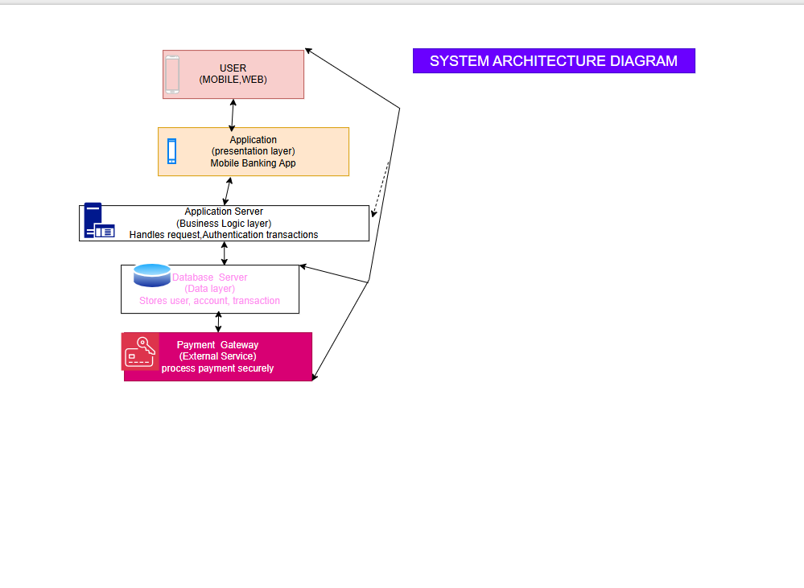

4. UML DIAGRAMS

Use Case Diagram

The use case diagram illustrates interactions between customers and administrators with the banking system.

Functions include:

* Register
* Login
* Verify OTP
* Check Balance
* Transfer Money
* Pay Bills
* View Transaction History
* Update Profile
* Manage Users
* Generate Reports

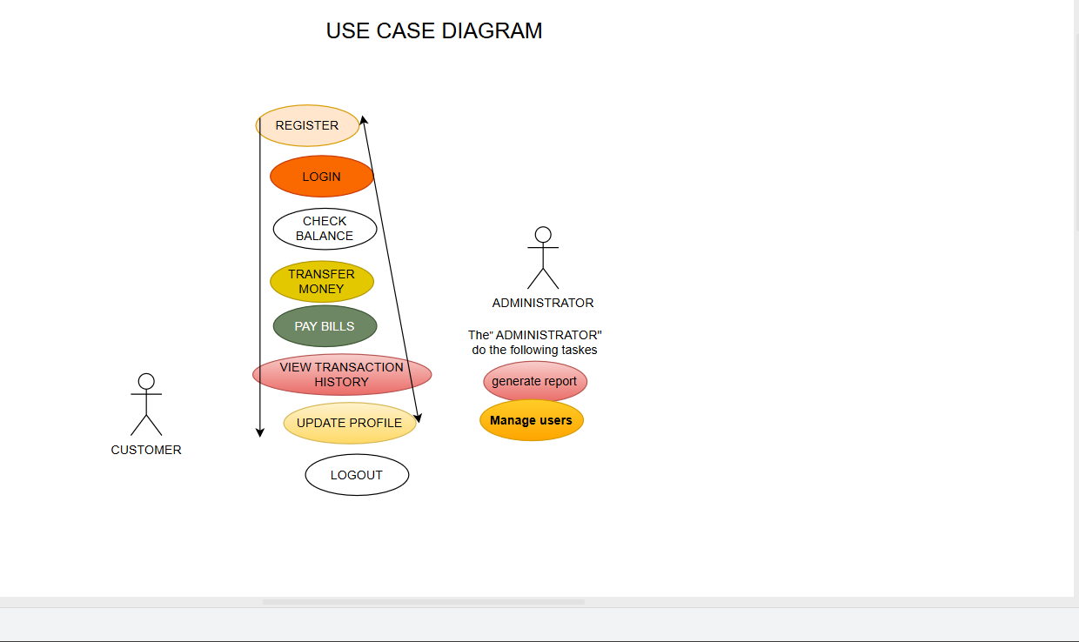

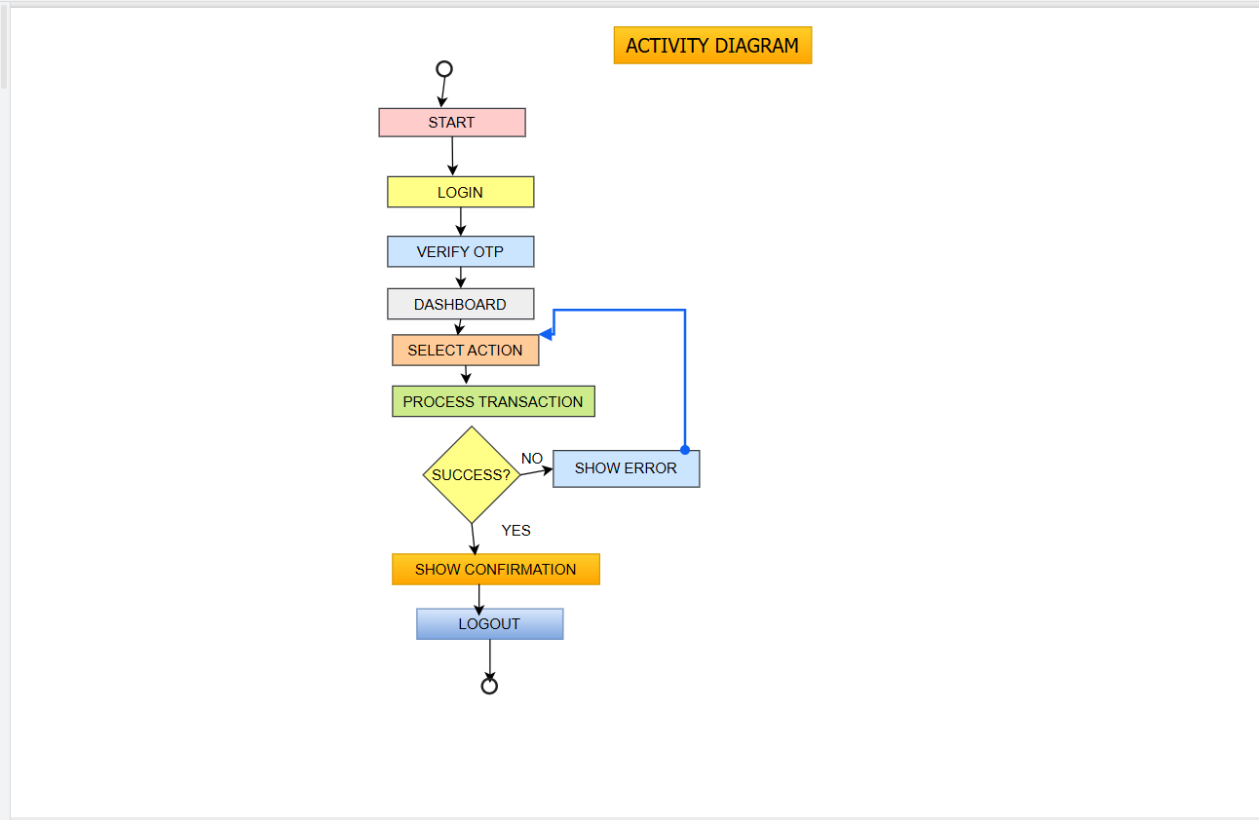

Activity Diagram

The activity diagram describes the process flow from login to transaction completion

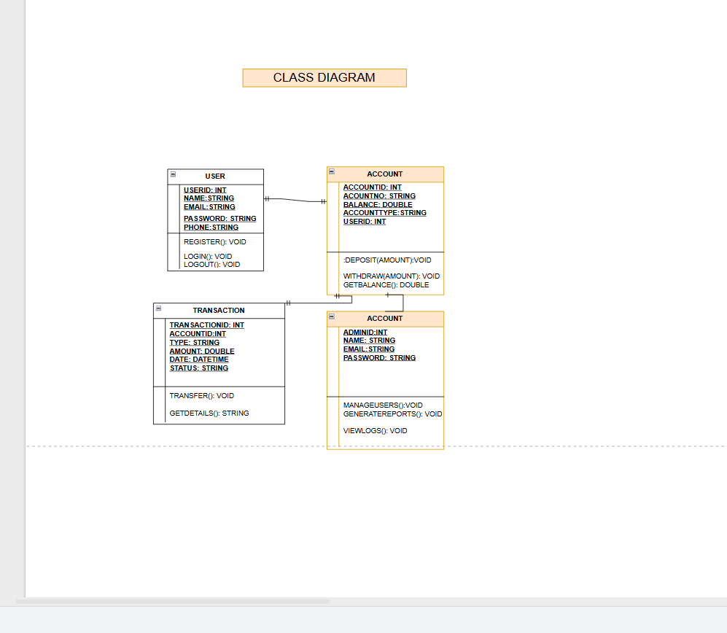

The class diagram represents the relationships among User, Account, Transaction, Notification, and Administrator classes.

5. PROTOTYPE DEVELOPMENT

The system prototype was developed using Figma.

Screen 1 – Splash Screen

Provides the welcome interface for users.

Screen 2 – Login Screen

Allows registered users to access their accounts.

Screen 3 – Sign Up Screen

Allows new users to create accounts.

Screen 4 – Dashboard

Displays available banking services.

Screen 5 – Forgot Password

Helps users recover forgotten passwords.

Screen 6 – Verify Account

Verifies user identity using OTP.

Screen 7 – Recover Password

Allows password reset.

Screen 8 – Transfer Money

Enables users to transfer funds.

Screen 9 – Transaction History

Displays previous transactions.

Screen 10 – Profile Settings

Allows users to manage personal information.

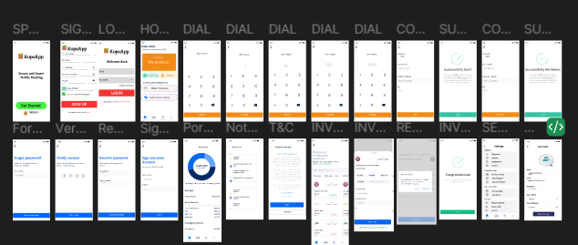

6. GIT AND GITHUB INTEGRATION

A GitHub repository was created to store project files and maintain version control.

Benefits of GitHub include:

* Version management
* Collaboration
* Backup and recovery
* Project organization
https://github.com/leighumu1234-byte/PROG-102-PRINCIPLE-OF-SOFTWARE-ENGINEERING-BSEM1201FGROUP7.git

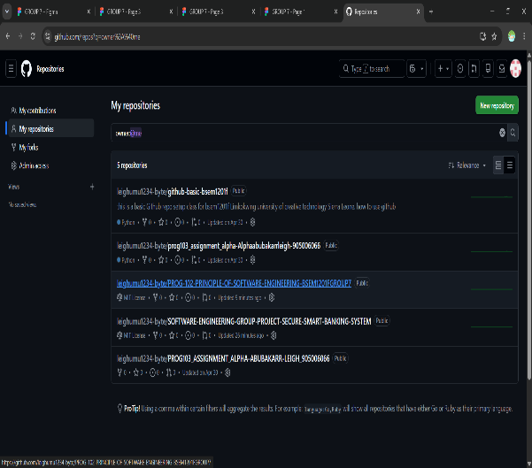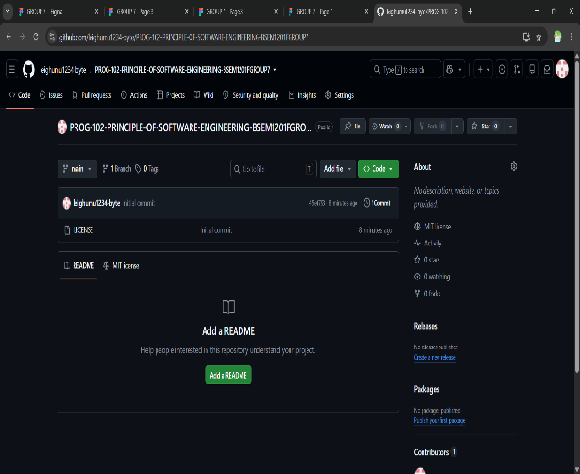

7. PROJECT MANAGEMENT

Gantt Chart
The Gantt chart was used to schedule project activities including planning, design, development, testing, documentation, and presentation.

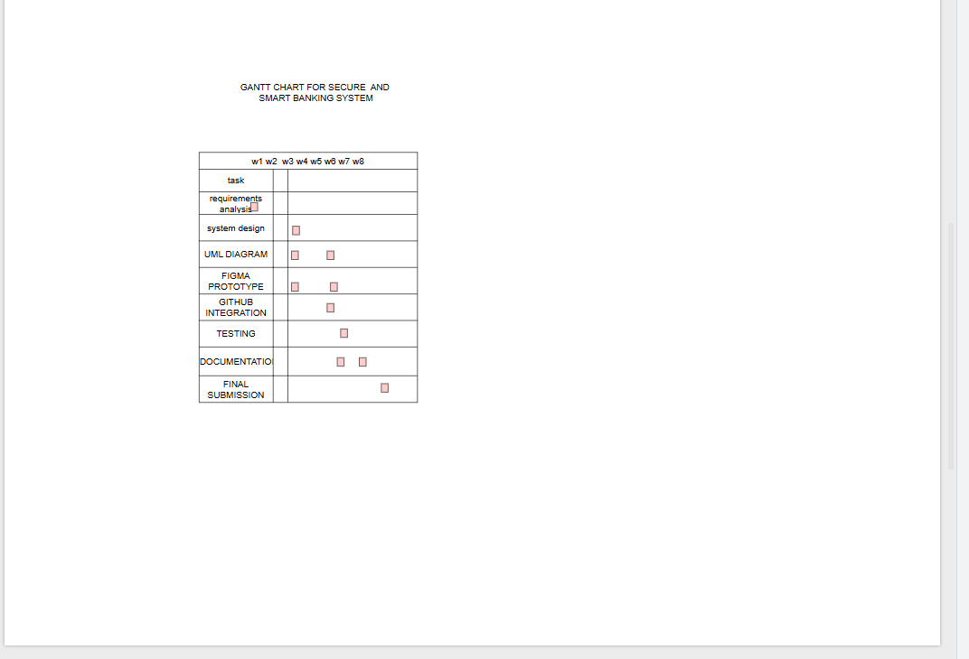

The network diagram was used to illustrate task dependencies throughout the project.

NETWORK DIAGRAM
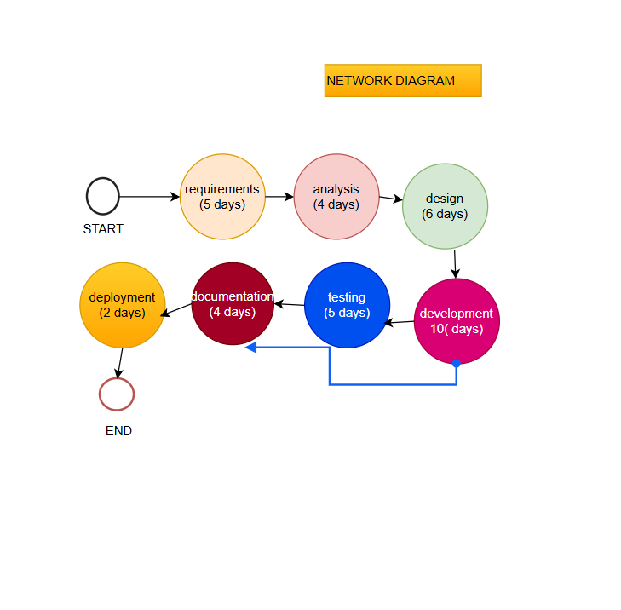

8. LICENSE, DESIGN QUALITY AND SDG RELEVANCE

Software License

The MIT License was selected because it allows modification, distribution, and reuse while maintaining proper attribution.

Design Quality

The prototype uses a clean and consistent user interface. Navigation is simple and user-friendly, ensuring a positive user experience.

SDG Relevance

This project supports Sustainable Development Goal 9 (Industry, Innovation and Infrastructure) by promoting digital innovation and improving access to financial services.

9. CONCLUSION

The Secure and Smart Banking System provides a secure and efficient solution for modern banking. The system improves accessibility, reduces operational challenges, and enhances customer convenience through digital technology. The project demonstrates the practical application of software engineering principles in solving real-world problems.

10. REFERENCES

Sommerville, I. Software Engineering.

United Nations Sustainable Development Goals Documentation.

GitHub Documentation.

Figma Documentation.

Banking Security Research Publications.

